**Project Design Phase**

**Solution Architecture**

|  |  |
| --- | --- |
| Date | 28 June 2025 |
| Team ID | LTVIP2025TMID40347 |
| Project Name | Revoluting liver care:Predicting liver cirrhoss using advanced machine learning technique |
| Maximum Marks | 4 Marks |

**Solution Architecture:**

Solution architecture is a complex process – with many sub-processes – that bridges the gap between business problems and technology solutions. Its goals are to:

* Find the best tech solution to solve existing business problems.
* Describe the structure, characteristics, behavior, and other aspects of the software to project stakeholders.
* Define features, development phases, and solution requirements.
* Provide specifications according to which the solution is defined, managed, and delivered.

**Example -** Revoluting liver care **Architecture Diagram:**

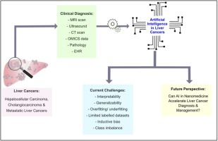

*Figure 1: Architecture and data flow of the*

**Reference: https://encryptedtbn0.gstatic.com/images?q=tbn:ANd9GcRQJbhcYyGoGcRclBwNjCbjLrp6vSQeGUNO9w&s**